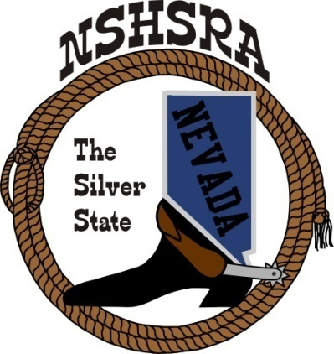
NEVADA STATE HIGH SCHOOL RODEO
FALL MEETING
Friday, July 30th, 7:00 pm – Executive Board
Saturday, July 31^{st,} 9:00 am – Full Board
Eureka Opera House
31 S. Main Street
Eureka, NV 89316

Pledge of Allegiance was said to start the meeting.

It was called to order at 7:00 p.

Roll call was taken and present were:

Ron Unger, Dale Owen, Curtis English, Shawn Silva, Jeff Garijo, Joey McKnight, Chris Christian and Madi Borkman

Absent was Mike Scronce.

Minutes of previous meetings
There were none as we didn’t have an executive board meeting at state.

State Finals Review
Curtis asked the board what was good and bad at state finals.

Jeff said we need to change the trap shoot to the evening instead of morning. Maybe switch it with the cutting and reined cow horse.

Curtis asked Jeff and Dale how working relations were with the facility. Both thought it went well.

Jeff felt the awards ceremony should be held in the events center as the sound system and seating is already set up. He thinks that announcing who the winners are earlier to speed up the National paperwork process. Also, might want to start the short go performance earlier at 8:00 a.m.

Curtis wants to ask the other directors their opinion. He talked about the jackpots and putting them out to bid for next year. Also need to work on getting hay lined up for next year as there might be a shortage. We will need about 22 ton. We paid $150 a ton this year.

He also talked about the stock contractor bids and that we need to make sure they know about having separate pens for both the high school and jr. high. He said this year the contractor had to go get more stock.

A discussion was held regarding about not having adequate number of stock and paying him more for having to go get them.

Jeff made the motion to pay the contractor what was in the contract and not pay any extra. Madi 2nd the motion, a vote was taken and the motion passed.

Jeff said also that every rodeo including state needs to require chips be used for the stock draw that has numbers on them to match the number on all animals. Dale 2nd the motion, a vote was taken and the motion passed.

Dale asked if we should have a run sheet at each rodeo.

It was agreed that the qualifying rodeos don’t need one as we list all the extras
in each event.

The goats were discussed and it was said that they had not been weighed.

Joey said they were weighed and Jeff said he brought his scale down to use for
that purpose.

Joey asked who was responsible to check weights. He was told it’s the judges
responsibility to look at all stock.

Shawn asked if this board could inspect the stock ahead of time. Curtis agreed
that might be a good idea.

New by-laws review
We talked about a few line items.

Jeff made the motion to adopt the new bylaws with the few changes/corrections as ground rules until approved by the NHSRA. Ron 2nd, a vote was taken and the motion passed.

Tonopah by-laws
It was discussed that this club will have to turn in bylaws to be reviewed and
approved by the executive board to be recognized as a new club as per our
bylaws.

Discussed the Boulder City club and wanting to come back.

New ground rules to adopt from the national office
No new ground rules at this time.

Points system
Curtis wants to see a point system to give the kids the opportunity to be the
best they can bee. They need to be competitive all year.

A discussion followed about the decision should be what’s best for all the kids.

Madi said that she and the student board had put out a survey to all the
members about what they wanted to see for a point system. She said they just
did it, but the responses they have gotten, the majority want to see either the
points max raised or carry all.

A discussion was held about having average rodeos or going back to double
headers.

Two options were decided might be the best and will let the full board decide:

Option 1: All 14 be average rodeos taking your best 7 with a
possible 210 points to be earned into state.

Option 2: Double header rodeos, 28 in total, taking the best 20 rodeos with
200 points possible points earned into state.

Madi said the kids she talked to wanted the best 12 with 360 points possible.

Curtis talked about those events that kids didn’t get 2 scores or times not
being able to get average points.

A discussion followed.

Jeff made the motion to accept the two options to present to the board. Ron
2nd, a vote was taken and the motion passed.

State pointes were discussed and the board talked about using all points
earned at state finals and distributing between all go rounds and average and
not having bonus points. It would be between 55 and 52.5 depending on
which option for the state was chosen.

It was discussed having 25 points for each go round and average and having
20 for 1st go, 20 for 2nd go, 20 for short go and 30 for the average.

Madi made the motion for each round and average be 25 points and the remaining be bonus points. Shawn 2nd, a vote was taken with 3 yes and 4 no. The motion did not pass.

Jeff made the motion to have 20 points for 1st-short go’s and average at 30
with the remaining be bonus points. Ron 2nd. Discussion followed. A vote
was taken with 7 yes and 1 no. The motion passed.

Good of the Association
There was nothing.

Adjournment.
The meeting was adjourned at 10:23 p.m.

