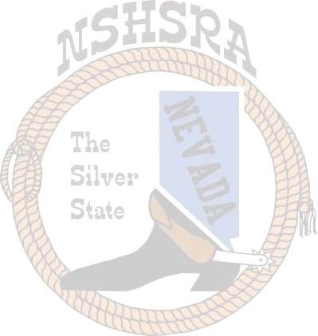
Nevada State High School & Jr. High School Rodeo Finals

2022 Order of Events
Performance 1 Performance 2
JH Pole Bending HS Pole Bending
HS Barrel Racing JH Barrel Racing
HS Tie Down Roping JH Ribbon Roping
JH Tie Down Roping HS Steer Wrestling
JH Boys Breakaway JH Chute Dogging
****LUNCH BREAK***** HS Breakaway
JH Girls Breakaway ****LUNCH BREAK*****
HS Team Roping JH Bareback Steer Riding
HS Bull Riding HS Bareback Riding
JH Bull Riding JH Team Roping
HS Goat Tying HS Saddle Bronc Riding
JH Boys Goat Tying JH Saddle Bronc Steer Riding
JH Girls Goat Tying
Performance 1 events will be the same in performance 3 and performance 2 events will be the same in performance 4. All 2nd go will be reversed except for cutting and reined cow horse.
The stock draw for the performances will be at 6:30 a.m. for all performances and top 15 finals.

