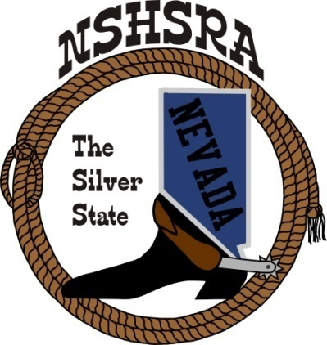
NEVADA STATE HIGH SCHOOL RODEO
FALL MEETING
Friday, July 29th, 7:00 pm – Executive Board
Saturday, July 30^{th,} 9:00 am – Full Board

Eureka Co. School District Admin Office
Board Room
660 Mathew Street
Eureka, NV 89316

AGENDA

- Pledge of Allegiance

- Call to order

- Roll call

- Minutes of previous meetings

- State Finals Review

- Good of the Association

- Adjournment.

