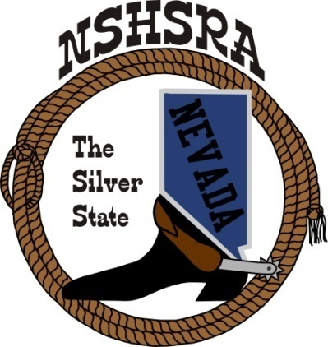
NEVADA STATE HIGH SCHOOL RODEO
FALL MEETING

Friday, July 29th, 7:00 pm – Executive Board
Saturday, July 30^{th,} 9:00 am – Full Board

Eureka Co. School District Admin Office
Board Room
660 Mathew Street
Eureka, NV 89316

AGENDA

Pledge of Allegiance

Call meeting to order

Roll call

a. Seating of delegates

b. Installation of new clubs

Approval of minutes from state meeting in May

Report of officers
- President
- Vice President
- State Secretary
- State Treasurer/report from state finals

Report of student officers:
a. Josie Lindburg-Queen
b. Brock Feyder-President
c. Desatoya Coombs -Vice President
d. Marquel Moser-Secretary
e. Christina Hendricks-Public Relations
f. Ella Roderick-JHS Representative

National HS Director’s Report

National JHS Director’s Report

Committee appointments

a. Prize committee appointments
b. Scholarship committee
c. Points committee
d. Queen committee
e. Student Advisory committee
f. Eligibility committee

Old Business
- Confirm 2022-23 rodeo schedule

New Business
- Secretary and treasurer positions
- Cutting, reining, bareback and saddle bronc steer riding , optional or mandatory
- Shooting points to accumulate during season or qualify top 4 at state finals
- Set dues. Current: Students: $26 Independent: $276 clubs: $200
- Independent fees over the $26 to be put into the prize fund
- Set assessments for 21-22 ($5 fee from rodeos that is split into general/scholarship/crisis funds divided equally)
- Host club for Cowboy Prom
- Point system

Good of the Association

Adjournment

