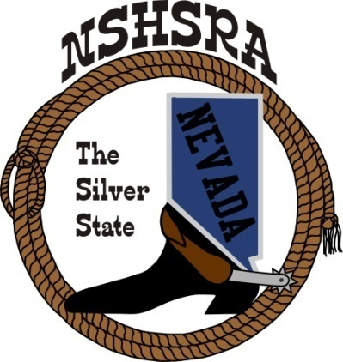
NEVADA STATE HIGH SCHOOL RODEO
FALL MEETING
Friday, July 29th, 7:00 pm – Executive Board
Saturday, July 30^{th,} 9:00 am – Full Board

Eureka Co. School District Admin Office
Board Room
660 Mathew Street
Eureka, NV 89316

The Pledge of Allegiance was said.

The meeting was called to order at 6:59 p.m.

Roll call was taken and present were:
Ron Unger, Dale Owen, Curtis English, Shawn Silva, Jeff Garijo (Will Delong, proxy), Nathan Morian and Chris Christian.

Brock Feyder was absent.

Minutes of previous meetings:
There were none from the state meeting.

State Finals Review:
Curtis thinks the state finals went well. The only feedback he got was some people want reining indoors next year. He met with Kim Peterson before the state finals and couldn’t do it because we would have to haul the dirt in and out for the reining.

A discussion followed.

Curtis would like some feedback from the kids.

He said he had received an email from Kim Peterson with nothing but good things to say and he likes our input.

Curtis said that maybe they could move the stripping chute to the middle or somewhere as they had problems with it.

He asked Dale that when they put in the new roping boxes, they need to be sure that where the barrier goes it’s in a place that doesn’t hinder or hurt a kid.

Good of the Association
Curtis talked about the scholarship fund and keeping back a percentage from the auction for the next year. Kathy asked if that was something the full board needed to decide on and Curtis said yes.

Shawn asked about someone to put on jackpots and/or practices during state finals next year. Curtis said he thinks we should ask for a percentage back to us.

Discussion followed.

The thought was a minimum bid of $2 per paid team in the team roping and 10% from the jackpots.

It was discussed that the outdoor arenas would be used for those.

It was discussed having a Cinch town with activities during state finals. Shawn thought it was something the student board could work on.

Curtis told the board about the problem we had at state with the all-around points. It was brought to our attention that we should have adjusted the reining points as there was only 5 events and not 7 best like the other events. It was corrected and the outcome did not change.

Ron asked the National office about it and they said it was our issue to handle.

Curtis talked about keeping the same point system as he thinks it worked well.

Curtis talked to the board about following our bylaws on bad checks. Need to make sure that if a club has a bad check that they communicate to Kathy so she can follow up on it. If someone makes this a habit, they will be on a cash only basis.

Curtis also discussed with the board about the clubs possibly having the cutting later on Fridays or maybe early in the morning on Saturday or Saturday after the rodeo. He will suggest it during the full board.

Adjournment
With nothing further to discuss, Nathan made the motion to adjourn the meeting. Chris 2nd and the meeting was adjourned at 8:58 p.m.

