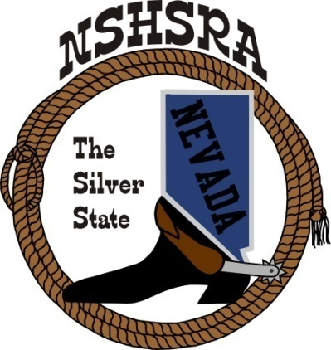
NEVADA STATE HIGH SCHOOL RODEO
MID WINTER MEETING

6:00 p.m. – Executive Board
9:00 a.m. Full Board

Mizpah Hotel
100 N. Main Street
Tonopah, NV

Friday, February 3, 2023

- Pledge of Allegiance

- Call meeting to order

- Roll call

- Approval of previous minutes

- Nationals update

- State Help - Arena Director’s, Judge’s, Flagger’s and Liaison

- Jr. High National Director

- State Schedule

- Stock for State – Shawn Silva

- Good of the Association

