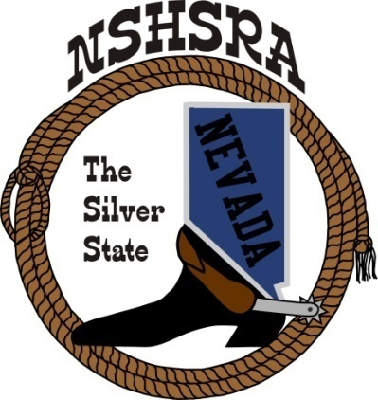
NEVADA STATE HIGH SCHOOL RODEO
MID WINTER MEETING

6:00 p.m. – Executive Board
9:00 a.m. Full Board

Tonopah Convention Center
301 Brougher Avenue
Tonopah, NV

Saturday, February 4, 2023

AGENDA

1. Pledge of Allegiance

2. Call meeting to order

3. a. Roll call
b. Seating of delegates
c. Installation of new clubs

4. Approval of minutes

5. Report officers
a. President
b. Vice President
c. State secretary
d. State Treasurer

6. Report of student officers:
a. Josie Lindburg-Queen
b. Brock Feyder-President
c. Desatoya Coombs-Vice President
d. Marquel Moser-Secretary
e. Christina Hendricks-Public Relations
f. Ella Roderick-JHS Representative

7. National HS Director’s Report

8. National JHS Director’s Report

9. Committee Reports
Prize Committee – Jeff Garijo, Nora Lee, Student Board, Kelly Christensen & Kathy
Gonzalez
Queen Committee – Julie Blasingame
Scholarship Committee – Kathy Gonzalez
Student Advisors – Dustin Feyder & Bill Process
Eligibility Committee – Kathy Gonzalez, Curtis English & Jessica Lancaster
By-laws Committee –Curtis English & Nathan Morian
State Finals Committee – Executive Board

10. Old Business

12. New Business
a. Stock Contractor bids for state finals
b. State finals points
c. State Finals Help – Arena Director’s, Judges and Flaggers
d. State Finals Schedule
e. Tentative rodeo schedule for 2023-2024 Season
f. Rough stock chute boss

13. Good of the Association

