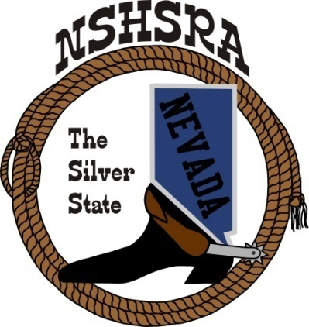
NEVADA STATE HIGH SCHOOL RODEO
MID WINTER MEETING

6:00 p.m. – Executive Board
Mizpah Hotel
100 N. Main Street
Tonopah, NV

Friday, February 3, 2023

The pledge of Allegiance was said.

The meeting was called to order at 5:56 p.m.

Roll call was take and present were:
Ron Unger, Dale Owen, Curtis English, Shawn Silva, Chris Christian, Nathan Morian and Jeff Garijo.

Mike Scronce and Brock Feyder were absent.

Approval of previous minutes:
Dale made the motion to approve the minutes. Jeff 2nd and the motion passed

HS National director
Ron said there are no changes for this year, but there will be a few rule changes for next year. He said they are setting up divisions for states to compete against each other for team points at the finals. The shooting sports made some changes to required attire for the competition. They will be allowed ball caps and tennis shoes, but no outerwear.

Curtis congratulated Ron on his 20-year award.

State Help - Arena Director’s, Judge’s, Flagger’s and Liaison
Curtis asked for recommendations for judges, flaggers and arena director. He would like to have Steve Beyer for the Arena Director. Jeff made the motion to accept the recommendation, Dale 2nd and the motion passed.

The board agreed that they would like the same flagger/judges that we had last year. Greg Bennett and Lance Cathcart. Kathy will contact them.

Kathy has a list of cutting/reining judges. She asked the board for any other names they might have. She will contact the names on her list to see if they are available.

Kathy will work on getting timers, photographer, concessions and vendors, hay, ambulance and tractor driver.

Jeff will work on getting the cutting cattle from the same place as last year. It was discussed that we would have to haul them. Ron said he might have a rig that would work. Robert said they might be able to help.

Kathy will ask the trap club if they would do the trap shooting for us.

Chris said he and Bill will help with the rifle shooting.

Jr. High National Director:
Dale went over the helmet language for the rough stock. They shouldn’t be using just a football helmet. Next year, there will be some changes and the vests must be padded, not just a leather one. He also told the board that the arenas will be switching for next year at Jr. High Nationals. He told them the places that the finals will be held and they are as follows:

JH Finals: 2024 & 2025 – Des Moines, Iowa
2026, 2027, 2028 & 2029 – Guthrie, Oklahoma, Lazy E Arena

HS Finals: 2024 & 2025 – Rock Springs, Wyoming
2026 & 2027 – Lincoln, Nebraska
2028 & 2029 – Gillette, Wyoming

State Schedule
Kathy handed it out and asked if we wanted to make any changes. Want to keep it the same as last year.

Stock for State – Shawn Silva
Wants to schedule a time to have the stock run through for the timed events and goats. Kids can help. It was discussed that maybe it could be on Wednesday evening. Wants to make sure that we have enough and they are all good. Board will ask some kids if they would be interested in doing that.

Good of the Association
Curtis talked about trying to get bids from anyone that was interested in putting on practices and jackpots. Kathy will get the letter together and have them look at it before she sends it out. He wants to be sure we put up signs if we have them about “no open container” to try and have no drinking during the jackpots.

Curtis also talked about the contract for state finals. This will be our last year in Winnemucca and he wants to send out bid letters to Fallon and Winnemucca. He asked if anyone had another facility that they’d like the letter sent to. It was decided that we would start with those two.

With nothing further to talk about, the motion to adjourn was made by Jeff. Dale 2nd and the meeting was adjourned at 8:25 p.m.

