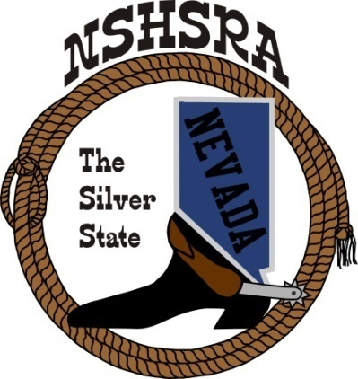
NEVADA STATE HIGH SCHOOL RODEO
STATE MEETING

6:00 pm Wednesday May 24th – Full Board

Exhibit Hall
Winnemucca, NV

AGENDA

1. Pledge of Allegiance

2. Call meeting to order

3. a. Roll call
b. Seating of delegates
c. Installation of new clubs

4. Approval of minutes

5. Report officers
a. President
b. Vice President
c. State secretary
d. State Treasurer

6. Report of student officers:
a. Josie Lindburg-Queen
b. Brock Feyder-President
c. Desatoya Coombs-Vice President
d. Marquel Moser-Secretary
e. Christina Hendricks-Public Relations
f. Ella Roderick-JHS Representative

7. National HS Director’s Report

8. National JHS Director’s Report

9. Committee Reports
Prize Committee – Nora Lee, Jeff Garijo, Kelly Christensen and Student Board
Queen Committee – Beth Webb
Scholarship Committee – Kathy Gonzalez
Eligibility Committee – Kathy Gonzalez, Jessica Lancaster
By-laws Committee –Curtis English & Nathan Morian
State Finals Committee – Executive Board

10. New Business
a. Person of the Year
b. Next year’s rodeo schedule
c. State Finals Help – job list
d. Arena and student event director job descriptions
e. Additional committee to add for the Crisis Fund
f. Bids for state finals
g. Nomination and Seating of New Officers
1. President
2. Vice President
3. Northern Rep
4. Central Rep
5. Southern Rep

12. Good of the Association

