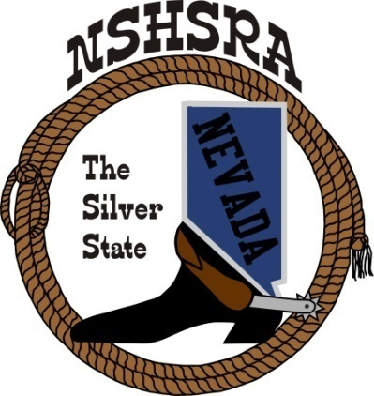
NEVADA STATE HIGH SCHOOL RODEO
FALL MEETING
Friday, July 28th, 7:00 pm – Executive Board
Saturday, July 29^{th,} 9:00 am – Full Board
Eureka Opera House
31 S. Main Street
Eureka, NV 89316

AGENDA

- Pledge of Allegiance

- Call to order

- Roll call

- Minutes of previous meetings

- State Finals Review

- New by-laws review

- New ground rules to adopt from the national office

- Points system

- Good of the Association

- Adjournment.

