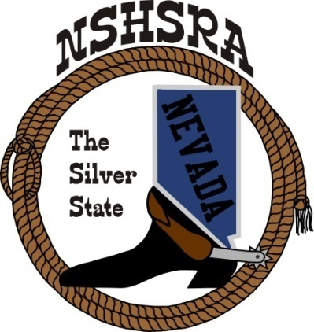
NEVADA STATE HIGH SCHOOL RODEO
FALL MEETING

Friday, July 28th, 7:00 pm – Executive Board
Saturday, July 29th, 9:00 am – Full Board
Eureka Opera House
31 S. Main Street
Eureka, NV 89316

AGENDA

Pledge of Allegiance

Call meeting to order

Roll call

a. Seating of delegates

b. Installation of new clubs

Approval of minutes from state meeting in May

Report of officers
- President
- Vice President
- State Secretary
- State Treasurer/report from state finals

Report of student officers:
a. Kayleigh Marshall-Queen
b. Amelia Lancaster-President
c. Ellie Webber-Vice President
d. Olivia Process-Secretary
e. Kylie Ann Behrendt-Public Relations
f. Raelee Christian-JHS Representative

National HS Director’s Report

National JHS Director’s Report

Committee appointments

a. Prize committee appointments
b. Scholarship committee
c. Points committee
d. Queen committee
e. Student Advisory committee
f. Eligibility committee
g. Crisis Fund committee
h. Bylaws committee

Old Business
- Confirm 2023-24 rodeo schedule
- By-laws update approval

New Business
- Secretary, points keeper and treasurer positions
- Cutting, reining, bareback and saddle bronc steer riding , optional or mandatory
- Shooting points to accumulate during season or qualify top 4 at state finals
- Set dues. Current: Students: $26 Independent: $276 clubs: $200
- Set assessments for 23-24 ($5 fee from rodeos that is split into general/scholarship/crisis funds divided equally)
- Letter from Mrs. Peek
- Host club for Cowboy Prom
- Point system
- State sponsors and side by side raffle

Good of the Association
Discussion about judges/flaggers and maybe adding a fee

Adjournment

