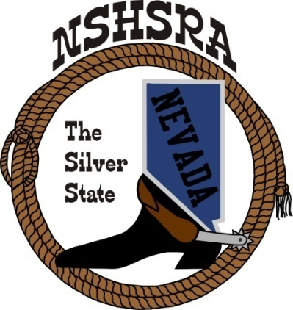
NEVADA STATE HIGH SCHOOL RODEO
FALL MEETING
Friday, July 28th, 7:00 pm – Executive Board
Saturday, July 29^{th,} 9:00 am – Full Board
Eureka Opera House
31 S. Main Street
Eureka, NV 89316

The Pledge of Allegiance was said

The meeting was called to order at 6:45 pm

Roll call was taken and present were:
Ron Unger, Dale Owen, Curtis English, Shawn Silva, Jessica Lancaster, Nora Lee, Chris Christian, Robert Steele, Will DeLong, Raelee Christian and Amelia Lancaster.

Absent was Mike Scronce

Minutes of previous meetings - none

State Finals Review
Curtis shared with the board a comparison from last years state finals and this years from Kelly. He said that last year we made a little money and this year, we did not. He thinks it was because of asking the fairgrounds to manage our stalls.

Robert said that we might want to negotiate the rate on managing the stalls.

There was a conversation about the cutting and reining judges and not being good. Curtis had asked the Mori family if they would help with getting the judges, cattle and such. He was also approached by TJ Shippy who would like to help as well.

He felt that by splitting the arena, that the rodeo ran better, except it was a very long day.

Jessica aske if we could run 2 arenas at a time. It could save time, but we would need more judges, arena director and timers.

The board talked about the rough stock taking too much time and that those contestants needed to be on the clock just like all the timed event contestants.

It was talked about putting most jr. high event in the afternoon so the high school could be getting ready for the cutting/reining events.

Amelia said that the student board wants to make a bigger deal out of our awards ceremony. Maybe move to the exhibit hall. It was discussed that the seating and sound system is better in the events center.

Curtis asked if we could have the notary show up a lot earlier to help with the line.

New by-laws review
Curtis went over a new by law for establishing the Crisis Fund committee. He wants the committee to have 4 adults and the student board president.

Robert said we need to make sure that all the directors know that there is also a National Crisis fund as well as a state fund.

Kathy will try to put the link on our website.

New ground rules to adopt from the national office
Ron went over the breakaway rule change coming from the National office. For the finals next year, it will be a bell collar catch only and the contestant can only use 1 loop. This is for high school only. He also said that the state can make up their own ground rule, but need to remember what the rule will be at Nationals.

A discussion followed on what would work the best.

The board will recommend to the full board that we have 1 loop only with a bell collar catch and if they have a leg in the loop, it would be a 5 second penalty.

Ron also said that the mid-winter meeting will be held in Branson, MO this year in January.

He said that Cinch had given each state $150 to give to someone that needed help. It was decided that the student board would be on the lookout for that person and let us know.

Points system
Amelia said that she held a meeting with the rest of the student board and they have been talking to the kids about how they would like the point system. She said the consensus is they want to be able to count 2/3 of their rodeos or 8-10 as their best to count for 240-300 possible points carried into state. They want more of their earned points to count and to leave state points as is.

A discussion followed.

Nora asked if we could change our rule that the kids go to 5 rodeos to qualify for state instead of 3.

More discussion followed about promoting rodeos and ways to do that.

Good of the Association
Amelia said the student board is talking about doing a remarkable kids rodeo hopefully at a couple of rodeos this years.

Curtis told the board of his idea to get help with getting more sponsors. Need to find someone to do that or hire a company that would do it for use.

Robert said we need to adjust our prizes to include more for our shooters. They pay all the fees, do all the fund raising and meet all the requirements like the rest of the kids and they only get qualifier buckles.

With nothing more to discuss, the meeting was adjourned at 10:11 pm.

