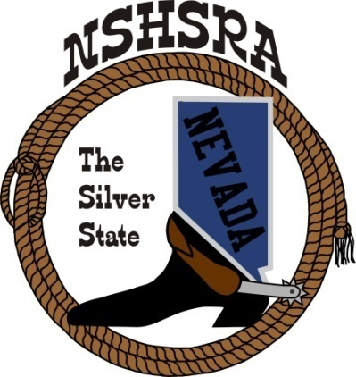
NEVADA STATE HIGH SCHOOL RODEO
MID WINTER MEETING

6:00 p.m. – Executive Board
9:00 a.m. Full Board

Tonopah Convention Center
301 Brougher Avenue
Tonopah, NV

Saturday, February 10, 2024

AGENDA

1. Pledge of Allegiance

2. Call meeting to order

3. a. Roll call
b. Seating of delegates
c. Installation of new clubs

4. Approval of minutes

5. Report officers
a. President
b. Vice President
c. State secretary
d. State Treasurer

6. Report of student officers:
a. Kayleigh Marshall-Queen
b. Amelia Lancaster-President
c. Ellie Webber-Vice President
d. Olivia Process-Secretary
e. Kylie Ann Behrendt-Public Relations
f. Raelee Christian-JHS Representative

7. National HS Director’s Report

8. National JHS Director’s Report

9. Committee Reports
Prize Committee –Nora Lee, Student Board & Kelly Christensen
Queen Committee – Julie Blasingame
Scholarship Committee – Kathy Gonzalez
Student Advisors – Bill Process
Eligibility Committee – Kathy Gonzalez, Curtis English & Jessica Lancaster
By-laws Committee –Curtis English & Nathan Morian
Crisis Fund Committee – Katie DeLong, Mindy Filippini, Carrie Eary, Jessica and
Amelia Lancaster
State Finals Committee – Executive Board

10. Old Business
Rodeo schedule

12. New Business
a. Stock Contractor bids for state finals
b. State Finals Schedule
c. Tentative rodeo schedule for 2024-2025 Season

13. Good of the Association

