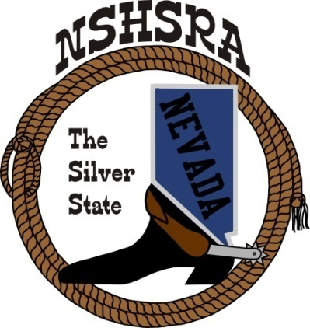
NEVADA STATE HIGH SCHOOL RODEO
MID WINTER MEETING

6:00 p.m. – Executive Board
9:00 a.m. Full Board

Mizpah Hotel
100 N. Main Street
Tonopah, NV

Friday, February 9, 2024

The pledge of Allegiance was said.

The meeting was called meeting to order at 6:10 p.m.

Roll call was taken and present were:
Ron Unger, Dale Owen, Curtis English, Shawn Silva, Jessica Lancaster, Nora Lee and Amelia Lancaster

Absent was Chris Christian.

Approval of previous minutes

Curtis asked if everyone had a chance to read the previous minutes and if anyone had any corrections or additions. There were no changes and Jessica made the motion to approve. Dale 2nd and the motion passed.

Nationals update
Ron went over all the rule changes that were approved at the National Mid-Winter meeting. He also talked about golf carts and the National office will now only let people 21 or over drive them. If any contestant or person caught driving that is not 21 years old will be disqualified. The same rule will apply for anyone that brings their own.

State Help - Arena Director’s, Judge’s, Flagger’s
Curtis talked about asking Steve Byer to be the arena director and asked if anyone had any other ideas. Other names that were suggested were Kyle Hendrix, Troy Christensen and Travis Kieckbusch.

Judges that were talked about getting were Greg Bennett and Lance Cathcart. Kathy will reach out to them.

Announcers were talked about. Beth Jepson, Jen Darrough, Mindy Goemmer and Brandon ? were names of possible choices. Kathy will reach out to Beth and Jen and Jessica will reach out to Mindy and Brandon ?.

A tractor driver was talked about. Jennifer Duke did it last year and Kathy was asked to reach out to her again. If she is unable, Kathy will reach out to Dusty Kepner.

Kathy will work on people for timing.

Curtis asked the board if they wanted to have practices/jackpots again. It was decided that we will send out bid letters again.

Jr. High National Director
Dale didn’t have anything else to add to Ron’s report.

State Schedule
Curtis talked about changing the schedule to help state run smoother and more efficiently. He wants to shorten the days a little and let the kids have more time to participate in some of the jackpots and other activities that may be going on. One of the changes will be to move the cutting and reining 1st and 2nd go rounds to Wednesday and the short go to Thursday after the rodeo. This was also recommended by TJ and Tucker Shippy and Amelia Lancaster.

We may also change some of the Queen contest parts and shooting around as well.

Good of the Association
TJ and Tucker Shippy and Amelia Lancaster spoke about getting a videographer for the cutting and reining for the judges to be able to review runs if they have questions and any point spreads of 4 or more. Most regular cutting shows have this and helps to eliminate any issues that may be missed. If we get one of these companies that they talked with to do it, they were also interested in doing the entire rodeo and even get live streaming for those family members that cannot travel to the finals. NSHSRA could probably charge for this service to recoup any costs involved in this service.

Nora asked the board about possibly being able to add money to the prize budget to be able to get hats for every contestant that enters state finals. The board agreed that this would be a good idea, but Curtis said that would be a decision that the full board would have to make.

With nothing more to discuss, Dale made the motion to adjourn. It was seconded and the meeting was adjourned at 9:30 p.m.

